

Implementation Highlights

**Account Information**

**Teacher’s Portal login** site is <https://portal.c8sciences.com/Login> . Your account is: XXX

1. You will receive an email with instructions to set your personal password. Your user name is your school email address.
2. When you will login, you will see this page. Click on Learning Groups to see the assessment and game play data on your students. Click in the other tiles to get information on physical exercises including 5n45, to add students, and to get help and background information.



**Students login** site is [**https://XXX.C8Sciences.com**](https://XXX.C8Sciences.com)**.** This should be bookmarked on every computer to facilitate student login.

**What to Expect and What to Do**

**Days 1-6: Getting started and baseline cognitive assessments**

The first two days the students log into ACTIVATE are the time everyone gets used to the login process and to the program in general. On the 3rd and 4th days, students will be given two cognitive assessment tests at the start of their sessions. After the tests are completed, the student will be able to play a computer training game to complete the session. Days 5 and 6 are test make-up days for students who were absent on either of the test days. If a student took a test on days 3 or 4 but our automatic scoring indicated that the test was invalid because the student appeared not to understand the test or not to be attending to the test, the test will also be repeated on day 5 or 6. You can login to your teacher portal to see which children are taking tests on the make-up days. The tests will be repeated 18 weeks after your students finish the first tests, so that they can be reassessed after 10-12 hours of Activate training. You can see descriptions of the tests below. ***Please create a testing-like classroom environment on assessment days.***

**Weeks 3 to 20: Schedule, Motivate and Coach – Teacher + ACTIVATE = Personal Trainer**

**ACTIVATE** automatically adjusts difficulty individually for every student to create their own training program.

**You Schedule** three Activate sessions per week and use 5n45 during the day. You can’t get stronger unless you go to the gym regularly!

**You Motivate** your students as a class and individually. We all need a little encouragement to keep up our visits to the gym!

**You Coach** students who need some assistance. You can easily identify which students need help with on click on your teacher portal and or simply by walking around the classroom, glancing at the computer screens and seeing which children are on lower game levels than their classmates.

**Play (and Know) the Games Your Students Will Play:** If you want to see become familiar with the cognitive training games your students will be doing, you can try them at our demo site. Here is how you do it:

* Log into the Teacher Portal – Portal.C8Sciences.com –



* Select Help Center -
* Select Demo Site where you will find login instructions.

The drop-down menus in the upper left allow you to move from game to game, and jump from level to level in each game (Please note that you can only move when a game is playing not when it is paused). The Demo Site can also be used to introduce the computer exercises as whole group instruction to get an understanding how the games play. Using the Demo Site is especially helpful for young learners. (**Note:** The Demonstration Site does not collect data, so students should not exercise on this site regularly.)

**See the Tests Your Students Will Take:** You can also try the four assessments on the demo site by selecting them on the drop down menu, although if you take the tests they will not be scored or any results saved. Here are descriptions of the assessments.

## There are four tests that make up the ACTIVATE assessments.

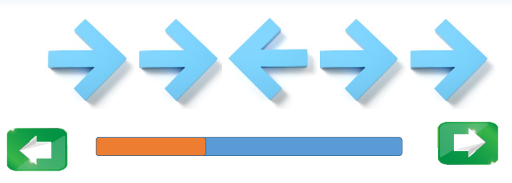Attention (The Flanker Task) - This is an assessment of self-regulation and attention. Students see five arrows in a row, all of which are pointing either to the left or right. Using the arrow keys on their keyboard, the students need to identify which way the arrow in the middle is pointing. To do this, they need to block out the arrows on either side of the middle arrow.

Self-Control (Go / No Go Test) - This is a simple and fun test of self- control or impulsivity. Students are instructed to tap the space bar as soon as they see the letter P - but to refrain from tapping when they see the letter R. Once they've completed a series of trials with "P" as the target, then they must switch and tap when they see R - but not P.

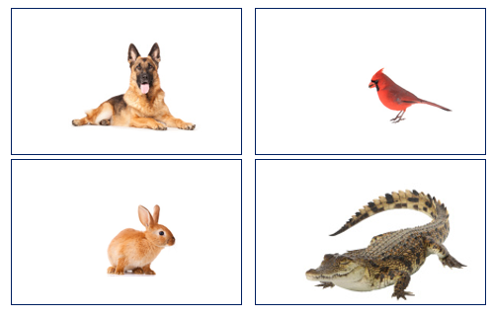Memory (Working Memory Test) -Working Memory is the "scratch pad of the mind" - the ability of the brain to keep and hold information needed to perform any given task - standing in a line, working on a math problem, or quietly sharpening a pencil. The Working Memory Test measures the strength of each student's "scratch pad" by asking them to repeat sequences of pictures shown on their screen in a different order than shown.

## 

 Balloon Analogue Risk Task (BART) – The BART not an NIH Toolbox test. The Balloon Analogue Risk Task is a measurement of risk-taking behavior. The BART models real-world risk behavior through a conceptual framework of balancing the potential for reward versus loss. The BART can be a predictor of increased risk and externalizing behavior in students acting without thinking.

**The 5n45 Classroom Cognitive Training Physical Exercises**

**5n45 Principles and Processes:**

1. Move to the beat using attention, self-control and memory – And have fun!
2. Start simple:
   1. Have students simply march or clap in time to a steady beat as you count it out in numbers or say “March” or “Clap.”
   2. March means to walk in place, without moving forward or backward, lifting your left arm when you lift your left foot, and your right arm when you lift your right foot.
   3. Start at a comfortable rate, then slow it down and let students feel the difference.
3. Mix movements:
   1. Make a movement pattern of two or more simple movements. For example, march-clap-march-clap-march-clap.
   2. Introduce a pause on a beat to further focus attention and self-control. For example, march-clap-march-clap-march-pause -march-clap.
   3. You can make the patterns more and more complex.
   4. You can teach more about staying on the beat by adding some movements to do twice in a beat. For example, march-clap-march-two claps-march-clap -march-two claps.
4. Make it shared between two students (adding social emotional learning):
   1. Two students face each other and alternate doing the movements in the pattern.
   2. For example, in march-clap-march-clap-march-pause -march-clap, one student does the march steps, the other does the claps, and they both pause.
5. Add memory:
   1. stop calling our or showing on the white board each movement so that they have to remember the movement
6. Let the students create movements and patterns:
   1. Let students make up a “crazy movement” to include in the pattern (e.g., one hand goes down and one goes up)
   2. Let students create the patterns or sequences of movements.
7. You can use the 5n45 cards document sent in your welcome email, and available on the teacher portal, to project movement sequences on the white board or wall in your room. Students can read them and/or follow the pictures in the sample progression of movement complexity.